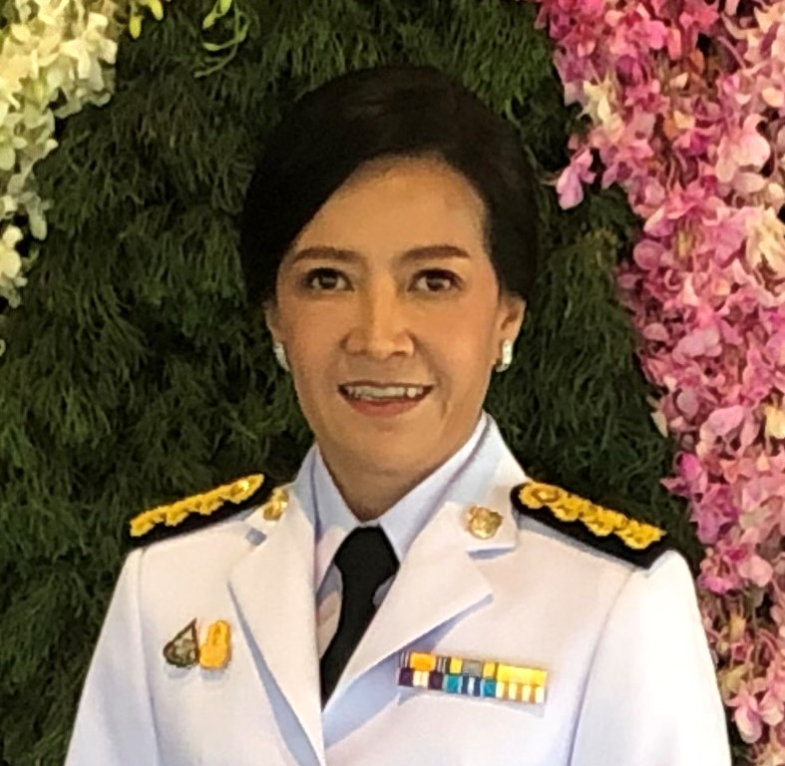 |  | Yanisa Ninlawong  General Manager – ANCA Manufacturing (Thailand) Ltd.
Profile  Yanisa Ninlawong is the General Manager at ANCA Manufacturing Thailand. She has a demonstrated history of working in the machinery industry. She brings ANCA a comprehensive skillset across people management, business planning, accounting, internal controls, and cultural leadership. She has intensively involved in HR functions and business development for more than 20 years especially for new business setting up.  Contact  PHONE:  +66 81 996 5003  WEBSITE:  https://machines.anca.com/  EMAIL:  Yanisa.Ninlawong@anca.com |  | EDUCATION  Rajamangala University of Technology  Bachelor’s Degree  Faculty of Accounting  WORK EXPERIENCE  ANCA Manufacturing (Thailand) Ltd. – General Manager  Duration: 2 years  ANCA Manufacturing (Thailand) Ltd. – Financial Controller & Admin Manager  Duration: 11 years  CEMEX (Thailand) Co., Ltd. – Institution Relations Manager  Duration: 2 years  Technology Training Co., Ltd. (Swinburne University - Thailand) – Deputy Director  Duration: 6 years  Accounting Management Consultant  Duration: 2 years  SGV – Na Thalang Co., Ltd. (A member firm of Arthur Andersen) – Senior Auditor  Duration: 4 years

